MAGNETIC DEFLECTION OF IONS AND THE POSSIBILITY OF DIRECT CONVERSION

A.E.ROBSON
Consultant/NRL

ABSTRACT

A cusp magnetic field can deflect ions into an external dump so that the first wall is exposed only to neutrons and x-rays. Limited confinement in the cusp ‘bottle’ lengthens the heat pulse on the dump surface by an order of magnitude. A thick, resistive chamber wall may allow much of the ion energy to be dissipated through eddy currents. Inductive coupling between the expanding plasma and an external circuit may allow some of the ion energy to be converted directly into electrical energy. If this could be done with 50% efficiency, the recirculating power fraction would be reduced from ~ 25% to zero.

HAPL 11 (NRL), March 3 & 4, 2005

WHY MAGNETIC DEFLECTION?

Fusion energy is released in three forms:
Neutrons 279 MJ (70%). Absorbed in depth in blanket
Ions 114 MJ
X-rays 6 MJ
400 MJ
from Perkins, HAPL 9 (UCLA)
Absorbed at surface of first wall

The materials problems at the first wall arise from the surface heating by the intense, short pulse of ions and x-rays. Magnetic deflection promises to:

- Remove the ion flux from the first wall, allowing it to be optimized for x-rays

- Extend the duration (× 10) of the heat pulse on an external dump.

MAGNETIC DEFLECTION BY A CUSP FIELD

Axis
Polar cusp (2)
Equatorial
(ring) cusp
Plasma expansion
initially spherical
Cloud deforms as it
encounters cusp field
Leaks out through the cusps:

Width of ring cusp ~ 2r_{L}
Radius of polar cusp ~ 2r_{L}
- THE CURVATURE OF THE FIELD LINES ENSURES MHD STABILITY

- IT IS NOT A GOOD PLASMA CONTAINER (WE DON’T WANT ONE)
MAGNETIC DEFLECTION WAS DEMONSTRATED AT NRL IN 1980 (see Pechacek et al., Phys. Rev. Lett. 45, 256 (1980))

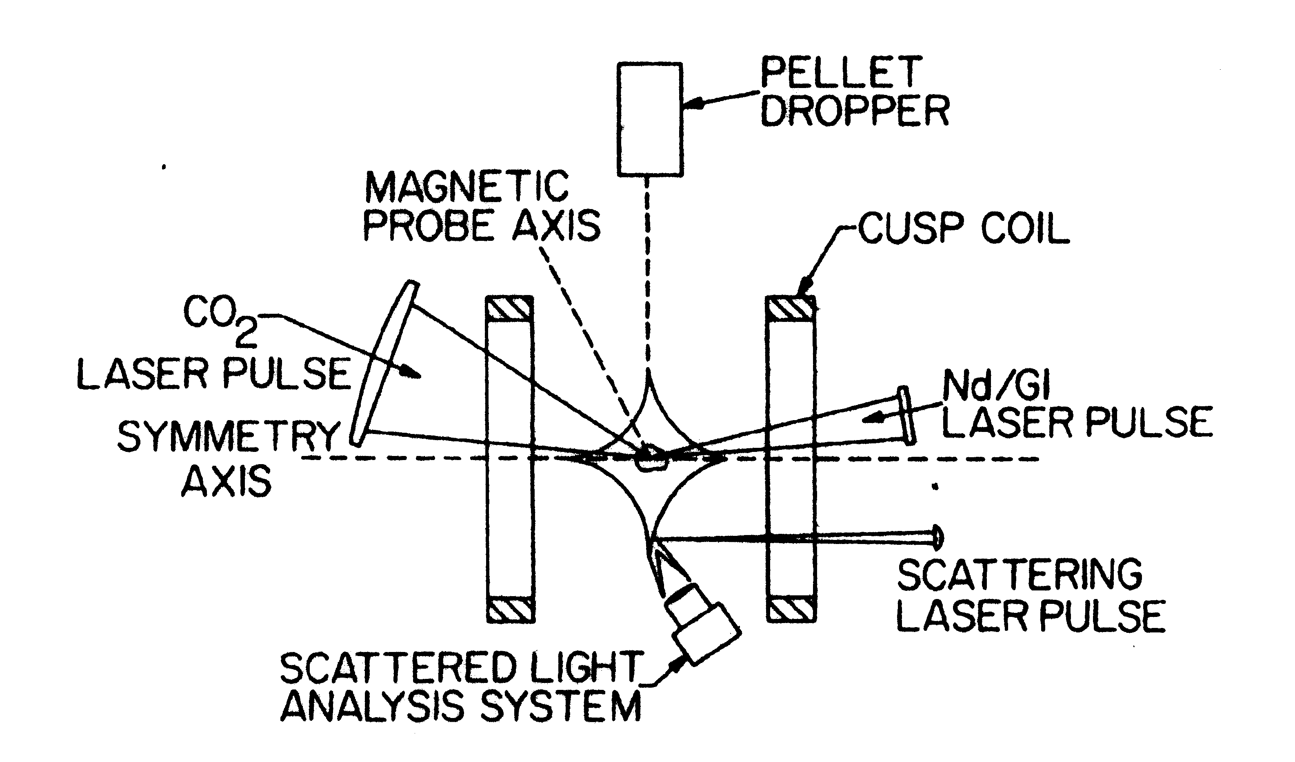
r_{coil} = 35 cm
B_{ring} = 2 kG
E_{ion} = 60 eV

A pure, fully ionized, D₂ plasma containing 2×10¹⁹ ions was generated at the center of a cusp magnetic bottle by irradiating a free-falling solid deuterium pellet with a 100-J Nd-glass laser pulse (to vaporize it) followed by a 1000-J CO₂ laser pulse (to ionize the vapor and heat the resulting plasma). The interaction of the plasma cloud with the magnetic field was studied with magnetic probes; the width of the ring cusp escape hole was measured by Thomson scattering.
PECHACEK’S EXPERIMENT: MAGNETIC PROBE DATA

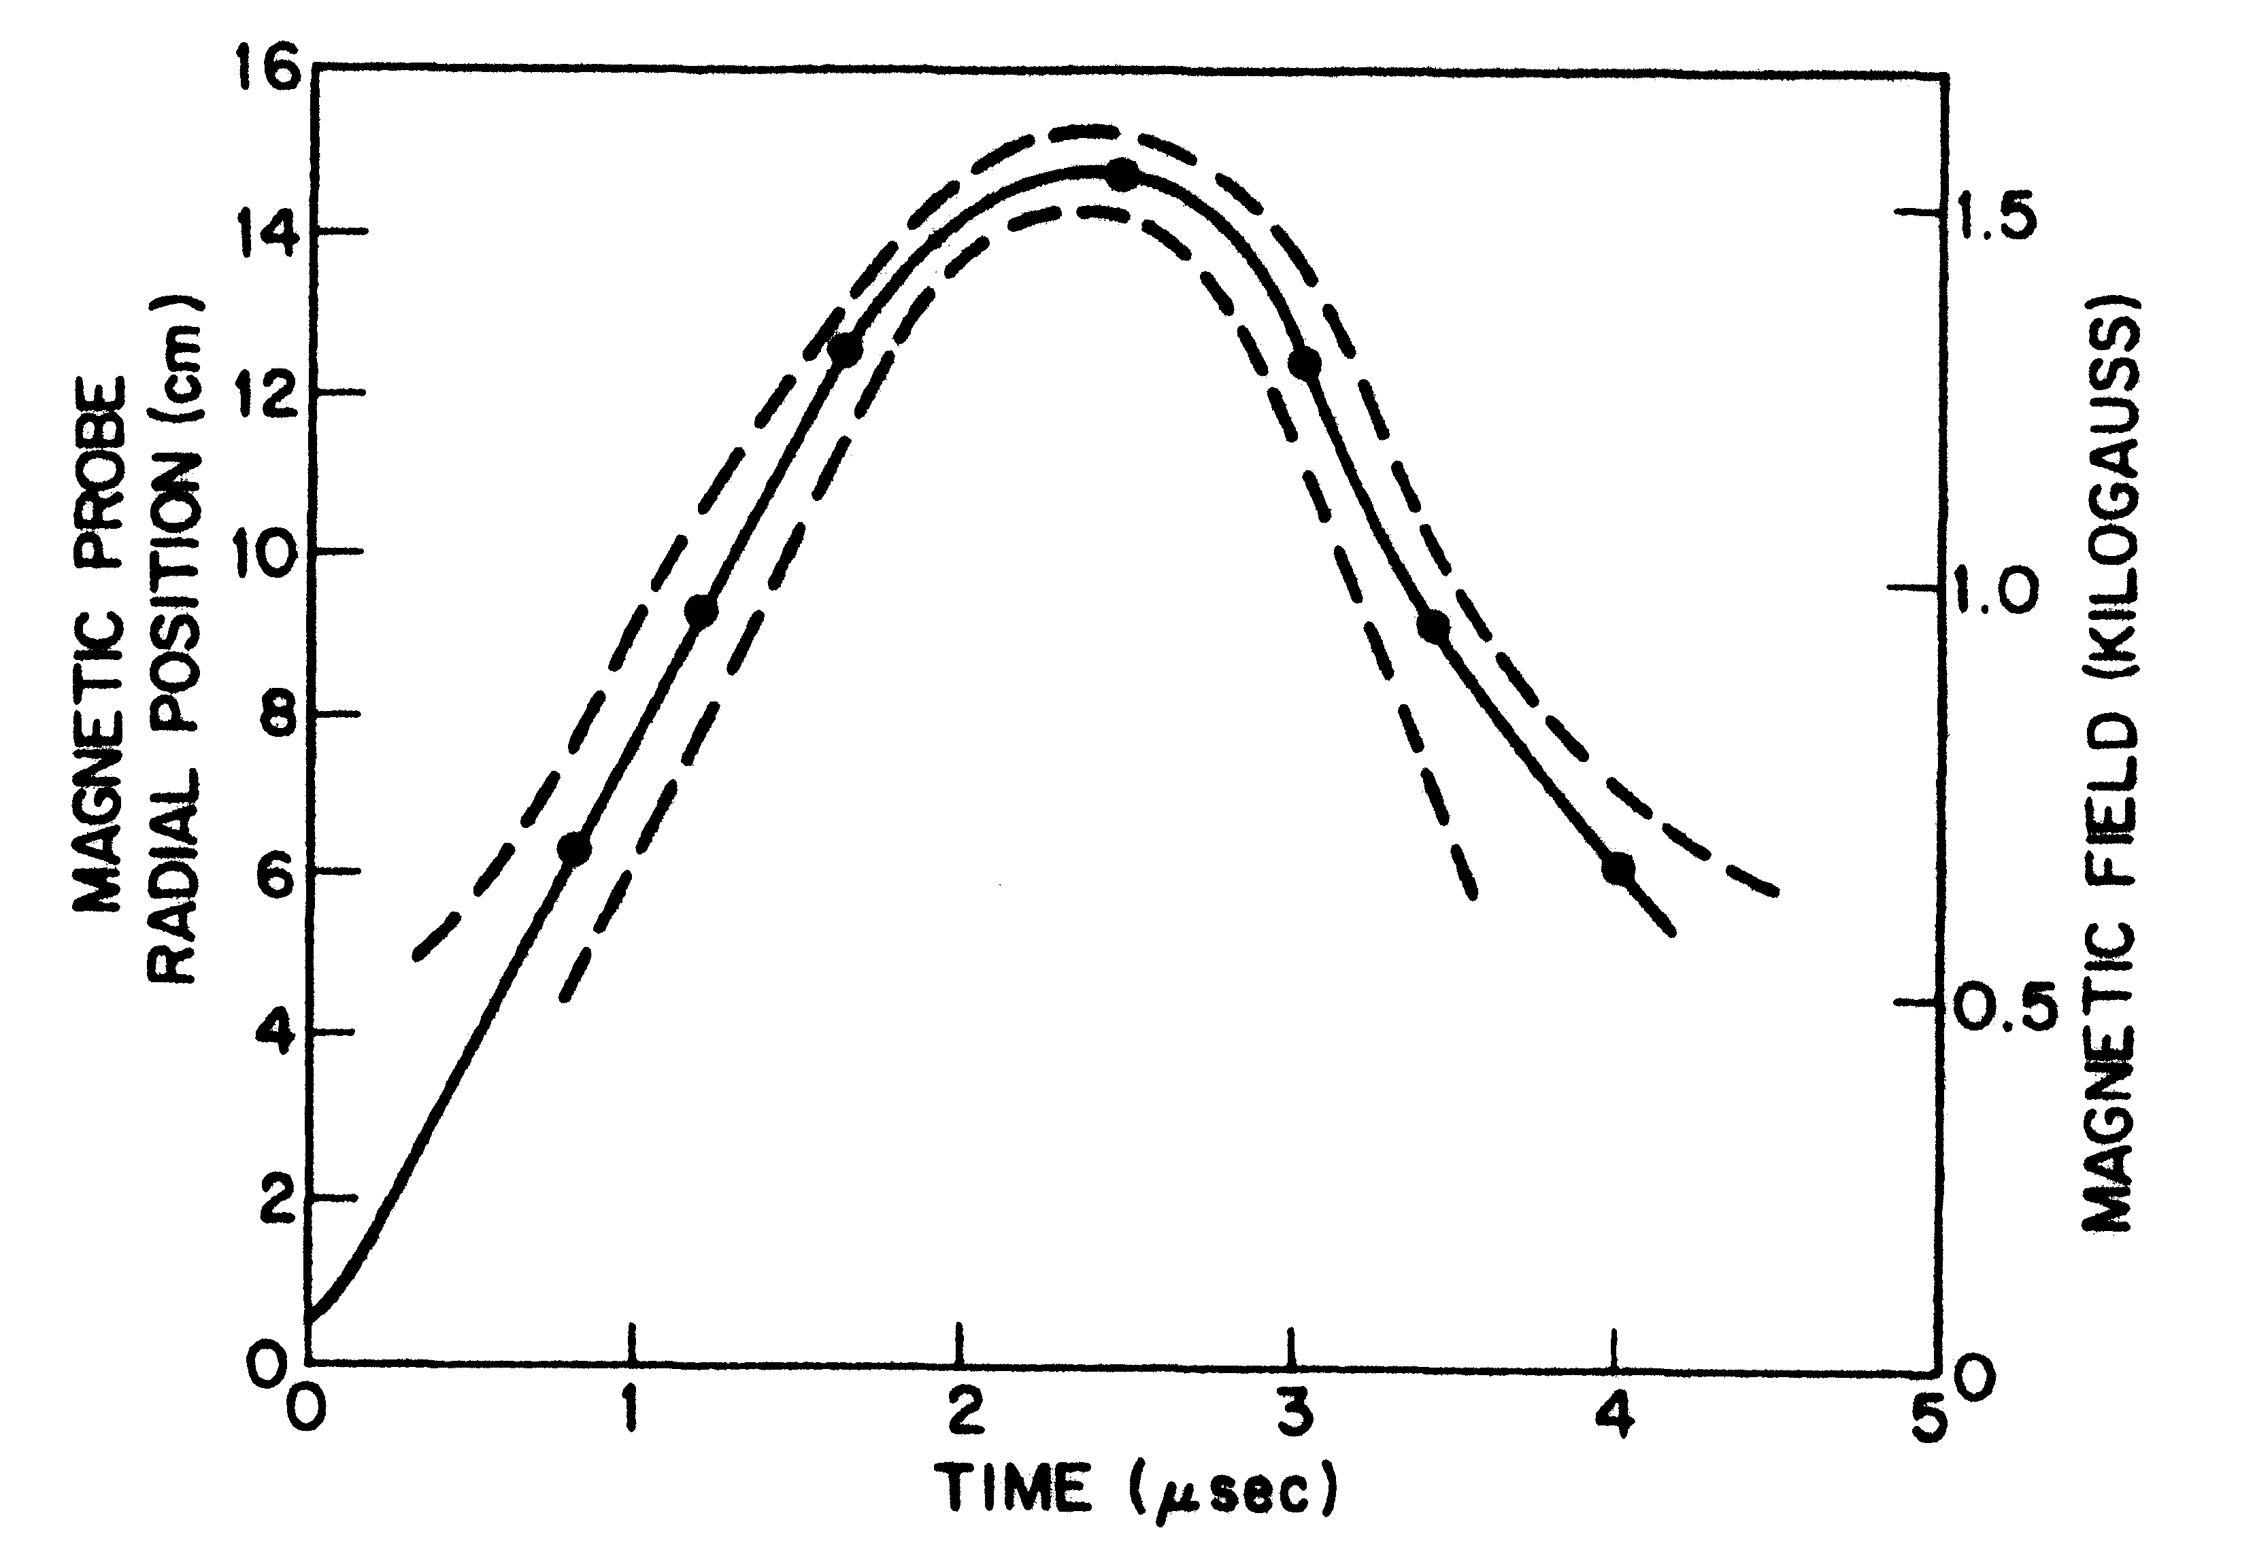
Plasma-field boundary vs time.
The dotted lines represent the width of the transition region
Plasma only here (B = 0)
Magnetic field only here
PECHACEK’S EXPERIMENT: CUSP WIDTH DATA

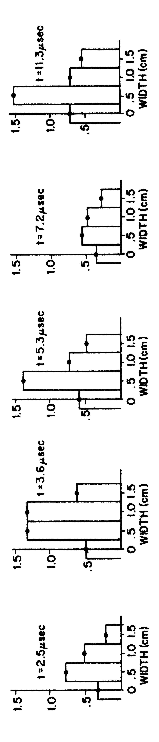
Thomson scattering measurements of electron density in the ring cusp (units are 10¹⁵ electrons/cm³)

- The width of the ring cusp was ~ 2r_{L} and remained constant for the duration of the experiment

- The results were reproducible and there was no evidence of MHD instability

4-COIL CUSP

4 coils allow independent control of ring and polar cusps

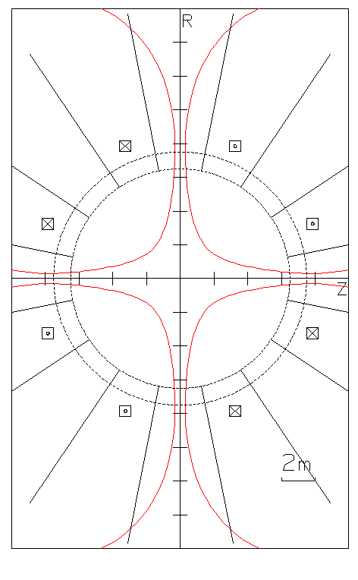
Ring cusp:
B_{r} = 8.9 kG
d = 60 cm
Polar cusp(s):
B_{z} = 17 kG
r = 32 cm
Surfaces of A = 2.75×10⁵ G-cm
(single-particle limit surfaces for 3.5 MeV alphas)
Axis
STRAWMAN SYSTEM

Chamber inner radius 6.5 m

Coils evenly spaced on sphere of radius 8.5 m

Coil currents ± 8 MA-turns

Cusp hole area 1
────────── ~ ─
Total surface area 20

CONCEPT #1: SIMPLE MAGNETIC DEFLECTION

1. Hot plasma ball formed
2. Plasma expands, compressing B-field against the first wall
3. Plasma is recompressed by field and driven out through the cusps
Superconducting coil
Conducting first wall
B_{initial}
B_{compressed}
plasma

- Energy is transferred reversibly to and from the B-field

- Ions carry their full energy to the dumps

SIMPLE MAGNETIC DEFLECTION –II

- The ion pulse is best absorbed by a high-Z refractory material (W)

- The x-ray pulse is best absorbed by a low-Z material (SiC, B₄C)

- Magnetic deflection allows these two functions to be separated

Surface heating equation is $ΔT=\frac{E}{{\text{At}}^{12}}\frac{2}{{\left(πKρc\right)}^{12}}$
(E = energy, A = area, t = time, K = thermal conductivity, ρ = density, c = heat capacity)

- If 112 MJ of ions hit 6.5 m radius tungsten first wall in 1 μs, ΔT ~ 12,400 ºC .

- If the cusp contains ions for ~ 20 transits, the same ions hitting a dump of the same area in 20 μs will give ΔT ~ 2,770 ºC

SIMPLE MAGNETIC DEFLECTION – III

- X-rays are now the only threat to the first wall

- If 6.07 MJ of x-rays with Perkins’s “Normal Target” spectrum hit
a 6.5 m radius wall in < 100 ps, surface temperature rise ΔT_{surface} is

Material | W | Fe | SiC | B₄C
ΔT_{surface} (ºC) | 3,140 | 820 | 212 | 63.2

- A steel surface with a layer of low-Z armor will experience a temperature rise ΔT_{interface}

Thickness, μm | SiC | B₄C
100 | 71.4 | 205
500 | 17.1 | 135
1000 | 8.41 | 105

CONCEPT #2: MAGNETO-RESISTIVE CONVERSION
1. Hot plasma ball formed
2. Plasma expands, driving B-field into the first wall
3. Reduced-energy plasma is driven out through the cusps as B-field diffuses out of first wall
Superconducting coil
Thick, resistive, first wall

- Plasma energy transferred to B-field is dissipated irreversibly in the first wall

- Ions carry reduced energy to the dumps

MAGNETO-RESISTIVE CONVERSION –II

- Assume field at the wall is a half-sine wave with T = 1μs

- The flux skin depth¹ is then δ(cm) = 3.6η (η in ohm-cm)

- For SiC with η ~ 20 ohm-cm @ 500 ºC, δ ~ 16 cm

- Efficiency of conversion E_{conv} = E₁(plasma → field) × E₂(field → heat)

- E₁(plasma → field) depends on the ion (plasma) flux vs time at the wall:
For a thin shell, E₁→ 1. For an adiabatic expansion, E₁ ~ 2δ/r_{wall} ~ 0.05
(the burn + debris spectrum will be closer to a thin shell)

- E₂ ~ 0.85 (see¹)

- We can probably get E_{conv} ~ 0.5, which would halve ΔT in the dumps

¹ from Heinz Knoepfel, Pulsed High Magnetic Fields (N. Holland, 1970), Ch. 4

CONCEPT #3: DIRECT CONVERSION (AFTER MIMA²)

3. Plasma escapes via cusps, current flows in pickup coil to trap B-field
S/c coil
i
V
1. Hot plasma
ball formed
Diode blocks current
4. B-field returns to initial state; excess energy flows into capacitor
Conducting FW
Pickup coil
2. Plasma expands, compressing B-field between loop and FW
DIRECT CONVERSION - II

- Efficiency of conversion E_{conv} = E₁(plasma → field) × E₂(field → circuit)

- E₁(plasma → field) depends on the ion (plasma) flux vs time at the wall

- E₂(field → circuit) depends on circuit details, but can be quite high

- Mima et al² assumed a thin shell and calculated E_{conv} = 0.825
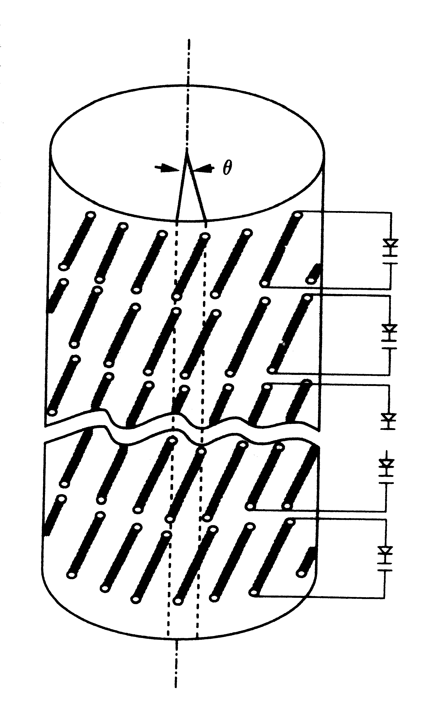
- We would be satisfied with E_{conv} = 0.33

Principal technical problem: high voltage (~ 20MV) on
pickup coil. Mima et al. suggest azimuthal sub-division of coil. We could divide into 60 circuits, each charging one laser.

² Mima et al, Fusion Technology 22, 56 (1992)

FINAL (PROVOCATIVE) COMMENTS

- NO UTILITY COMPANY WILL BE ENTHUSIASTIC ABOUT A POWER PLANT THAT REQUIRES ~ 25% OF ITS ELECTRICAL OUTPUT TO RUN ITSELF.

- IFE PRODUCES ~ 30% OF ITS ENERGY IN CHARGED PARTICLES, THAT IS, AS ELECTRICITY. TO CONVERT THIS ENERGY INTO HEAT AND THEN BACK INTO ELECTRICITY IS A WASTED OPPORTUNITY, IF NOT A SIN.

