The High Average Power Laser (HAPL) Program
March 20, 2002

Scientists at the Naval Research Laboratory, Lawrence Livermore National Laboratory, and other institutions are carrying out a multi-disciplinary program to develop high energy pulsed lasers and complementary technologies for fusion energy and defense applications ¹.

FUSION ENERGY
For fusion energy, an array of high-energy laser beams would symmetrically and directly illuminate a cryogenic target that has been injected into a chamber. The deuterium-tritium fuel in the target undergoes thermonuclear burn and the energy is used to generate electricity.
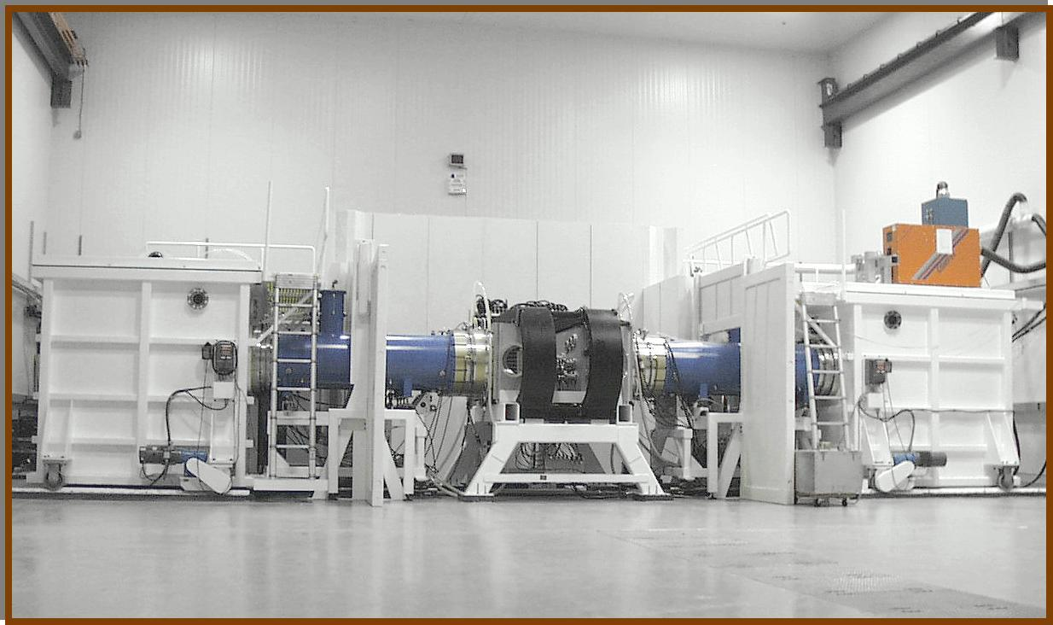
NRL “Electra”
KrF Laser

The attractiveness of this approach lies in its inherent simplicity, its separable architecture, and the modular nature of the laser driver. This lowers development costs and allows multiple options for the lasers, targets, and chambers. We are pursuing an integrated research program that develops the main components simultaneously. This “systems approach” ensures that the key interface issues are properly addressed. Examples of these include the laser/final optics interface, and target injection into the chamber. While there are still many science and engineering challenges, we have recently made significant advances in all areas.

We have formulated a three-phase program to develop this concept. Phase I is the present five year, $25 M/year (as recommended by FESAC) “Proof of Principle” R & D program. Phase II will be the Integrated Research Experiment (IRE) that brings together the key components with a power-plant size laser beam line. Phase III will be a full-scale Engineering Test Facility (ETF). The ETF should be complete around 2020. It would evaluate components and demonstrate fusion power.

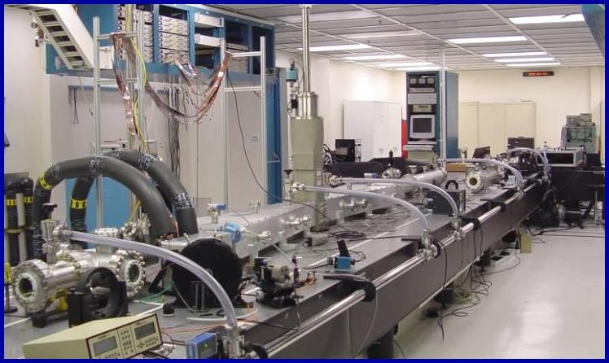
LLNL “Mercury”
DPSSL Laser

DEFENSE APPLICATIONS for HAPL S&T
Two lasers are being developed for this program: krypton fluoride lasers (KrF) at NRL, and diode pumped solid-state lasers (DPSSL) at LLNL. These will provide the next generation technologies for future large-scale NNSA laser facilities. The repetitive pulse capability would allow more detailed, highly accurate laser-matter studies in regimes of interest to defense research. The advanced solid state switch under development for the KrF laser would have applications in all-electric combat vehicles and systems. Large, powerful diode arrays, such as those being deployed on Mercury, are also useful for Directed Energy purposes. In the non-laser arena, this program is developing methods to fabricate direct drive targets for ignition on the NIF. The program is also developing target tracking and laser guidance systems; long-lived, high damage- threshold laser optics; studying the effects of intense energetic particles/x-rays on materials, and developing benchmarked multi dimensional codes to study the release of large energies in confined chambers.

This is an integrated, cutting edge science and technology program dedicated to providing solutions for the Nation’s long term energy needs and also new capabilities for the Nation’s defense.

_______________________________________
1. Other participants:

National Labs: Los Alamos National Laboratory, Oak Ridge National Laboratory, Sandia National Laboratory, Princeton Plasma Physics Laboratory.
Industry: General Atomics, Titan-Pulse Sciences Division, Schafer Corp, Science Applications International Corp, Northrop-Grumman Corp, Coherent, Inc.
University: UC San Diego, Univ of Wisconsin, UCLA, and Univ of Rochester Laboratory for Laser Energetics

