The High Average Power Laser Program
August 13, 2001

The High Average Power Laser Program is a coordinated, focussed multi-lab effort to develop a repetitively pulsed laser facility for inertial fusion energy and other DOE/DOD needs. The program has been established by scientists at the Naval Research Laboratory and Lawrence Livermore National Laboratory in conjunction with researchers at other National labs, universities, and industry¹.

A principal application for high average power lasers is inertial fusion energy (Laser IFE). The laser would symmetrically and directly illuminate a cryogenic target that has been injected into a chamber. The target is compressed and heated to undergo thermonuclear burn, and the released energy is converted to electricity. Recent advances in target design, target experiments, lasers, and associated technologies make this a promising approach for a viable energy source.
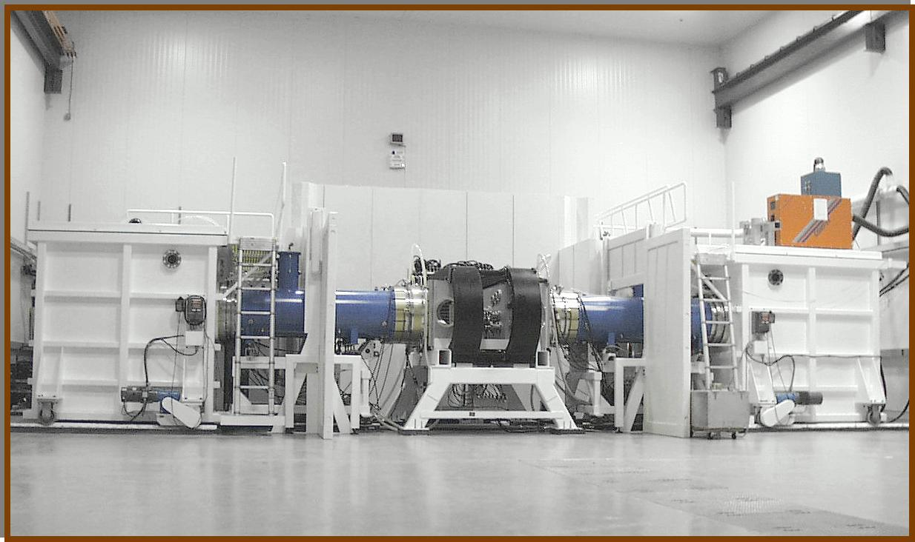
The Electra KrF Laser (NRL)

In 1999 and 2000 the program concentrated on the two most promising laser concepts: The krypton fluoride lasers (KrF) under development at NRL, and diode pumped solid state lasers (DPPSL) under development at LLNL. In 2001 the program was expanded to address all the critical components in Laser IFE, including target fabrication, target injection, final optics, and fusion chamber research. This approach assures that the components for Laser IFE are developed as coherent integrated system. The goal of this “Phase I” effort is to perform the cutting edge R & D necessary to evaluate and develop this approach. This Laser Program is closely coupled to the Heavy Ion Beam Program in DOE/OFES. The synergy and cross- fertilization between the two ensures a complete and robust US Inertial Fusion Energy program.
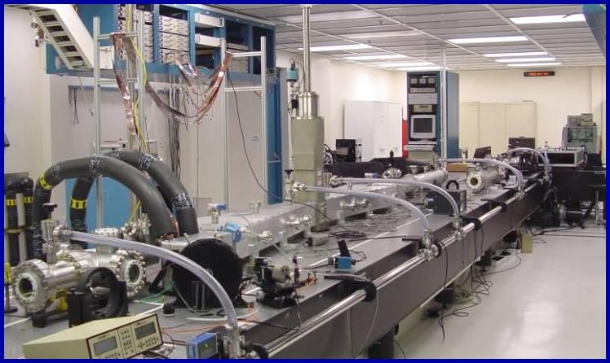
Mercury Diode Pumped Solid State Laser (LLNL)

Phase I should be essentially complete in 5 years with the $30M/year funding recommended by FESAC. At that time we would be prepared to go to Phase II, the Integrated Research Experiment (IRE). This will provide an demonstration that the essential reactor components can operate together with the required efficiency and precision. It would include a full-scale laser module for a reactor, and could be completed by 2012. If successful, we would proceed to Phase III, a full-scale test Engineering Test Facility (ETF). The ETF would evaluate and validate the materials and components required for a fusion system. It could be finished in about 2020, and would also be used to demonstrate fusion electrical power. Through all phases of this work the economic and environmental issues will be considered with equal weight to the scientific and technical challenges. The goal is to develop an attractive solution to the Nation’s long term energy needs.
_______________________________________
1. Partners are: General Atomics, The University of Wisconsin, UC San Diego, UCLA, Titan-Pulse Sciences, Schafer Corp, Sandia National Laboratory, Los Alamos National Laboratory, Oak Ridge National Laboratory, Science Applications International Corporation, Princeton Plasma Physics Laboratory, The University of Rochester Laboratory for Laser Energetics, Coherent Systems, Inc, Litton-Airtron and Crystal Systems.

